# Exercise Solutions

1. Story Variables (VELA project, <http://csforall.sri.com/>)

a)

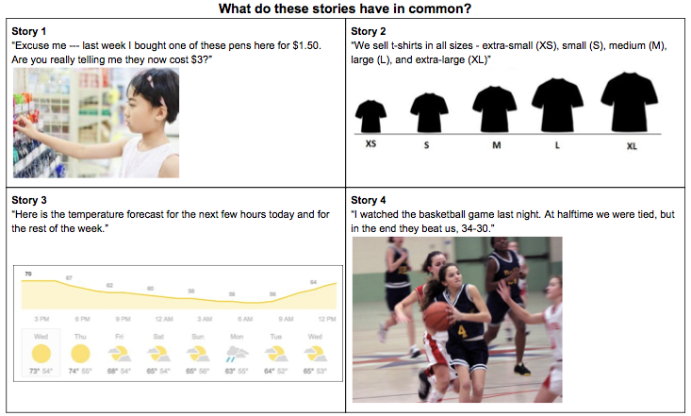

| **Answer:**  **They all have something that changes over time** |
| --- |

b) What is a variable?

| **A variable is something that stores a data value and can be manipulated over the duration of a program.** |
| --- |

c) Fill out the following table about variables in these stories (try a couple of stories, then discuss as a group)

| Story | Describe a specific element or quantity in the story that is changing | What would be a good, meaningful name for the variable | What are some of the ***specific values*** of the variable within the story? | How would you describe ***all possible values*** the variable might take? |
| --- | --- | --- | --- | --- |
|  | Price of a pen | Pen price, cost, price, cost in dollars, dollar cost | $1.50 (Last week)  $3.00 (Now) | Any monetary value. But probably not more than a million dollars! |
|  | How big the t-shirts are | Size, Shirt size | XS, S, M, L, XL | Any valid size described using letters or numbers or a combination, like 8P or 10T |
|  | Maximum and minimum temperature for different days of the week, Temperature for different times during the day today | Temperature, Weather, Maximum temperature, Minimum temperature | “73”, “65”, “58”, “63”, etc. - values for temperature  “Sunny”, “Cloudy”, “Partially cloudy” - values for weather | Any reasonable value for temperature, or any feasible weather conditions like “stormy”, “snowy”, “rainy”, etc. |
|  | Our team’s score and other team’s score | Team A score, Team B score  Home score, Opponent score | 0,0 (at start of game)  Same scores (Home score = Opponent score) (at halftime)  34,30 (at end of game) | Scores can be positive whole numbers |
| 5. Mario Game or another video game | Lives, Level, Position | Number of lives  Current level  X position  Y position | N/A | Lives: Positive whole number  Current Level: World (Number) - (Number)  X Position: Integer  Y Position: Integer |

1. A day has 86,400 seconds (24⨉60⨉60). Given a number of seconds in the range of 0 to 1,000,000 seconds, your program should print the time as days, hours, minutes, and seconds for a 24­ hour clock. For example, 70,000 seconds is 0 days, 19 hours, 26 minutes, and 40 seconds. Your program should have user input that is the number of seconds to convert, and then use that number in your calculations. If your results are W, X, Y, and Z, then your output should be displayed as :

The time is W days, X hours, Y minutes, and Z seconds.

Write an algorithm in pseudocode for the program above. Imagine how a sample run of your program would look like.

| **Pseudocode:**  Declare ‘numberOfSeconds’ variable and read the user input  Declare variables ‘numberOfDays’, ‘numberOfHours’ and ‘numberOfMinutes’  numberOfDays = numberOfSeconds/86,400 then update: numberOfSeconds = numberOfSeconds % 86,400  numberOfHours = numberOfSeconds/3600 then update: numberOfSeconds = numberOfSeconds % 3600  numberOfMinutes = numberOfSeconds/60 then update: numberOfSeconds = numberOfSeconds % 60  Print “The time is ” + numberOfDays + “ days, “ + numberOfHours + “ hours, “ + numberOfMinutes + “ minutes, and “ + numberOfSeconds + “ seconds.” |
| --- |

| **Sample Run:**  User input: 500000  Output: The time is 5 days, 18 hours, 53 minutes, and 20 seconds. |
| --- |

1. Write an algorithm in pseudocode for the following program. The program will start by asking the user to enter 10 characters. Letters ‘a’, ‘e’, ‘i’, ‘o’, ‘u’ in the English alphabet are vowels. The program should count and display the total number of vowels among the 10 characters entered by the user. For example, if the user entered *ILoveSadie*, then the program should display: You entered 6 vowels

| **Pseudocode:**  Ask user to input 10 characters  Read 10 characters  Declare and set numberOfVowelsSeen to zero  For each character input by user  If character is a vowel  Increment numberOfVowelsSeen by one  Print “You entered “ + numberOfVowelsSeen + “ vowels” |
| --- |

1. Spot the errors

a)

#include <iostream>

using namespace std;

int Main()

{

cout << "Hello, World!" << endl;

return 0;

}

b)

#include <iostream>

using namespace std;

int main

{

cout << "Hello, World!" << endl;

return 0;

}

c)

#include <iostream>

using namespace std;

int main()

{

cout << "Hello, World! << endl;

return 0;

}

d)

#include <iostream>

using namespace std;

int main()

{

cout << "Hello, World!" << endl

return 0;

}

e)

#include <iostream>

using namespace std;

int main()

{

cout << "Hello, World!" < endl;

return 0;

}